**Languages**

User should specify the language to use ATM

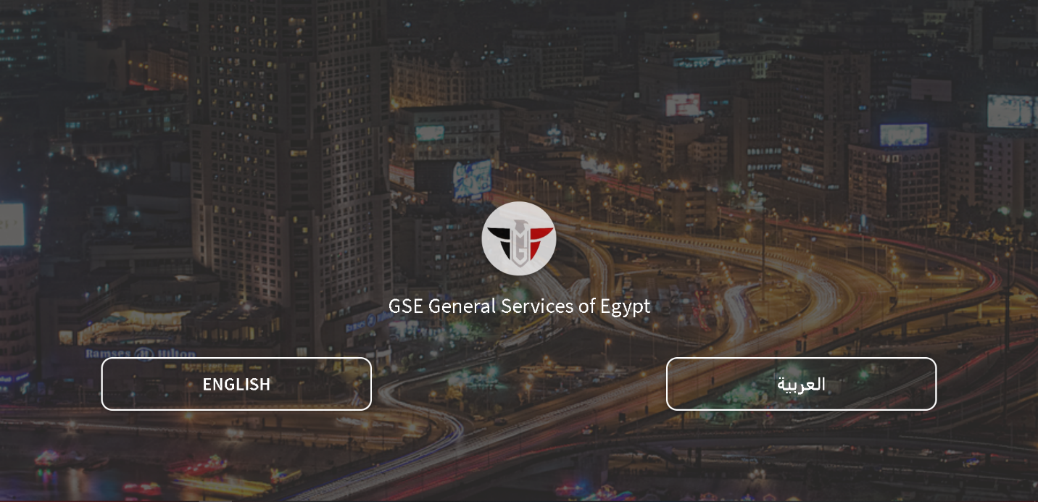

Then the system will redirect to the login page

**Login**

The user can log in using national id with the password which registered before then clicks on “login button”

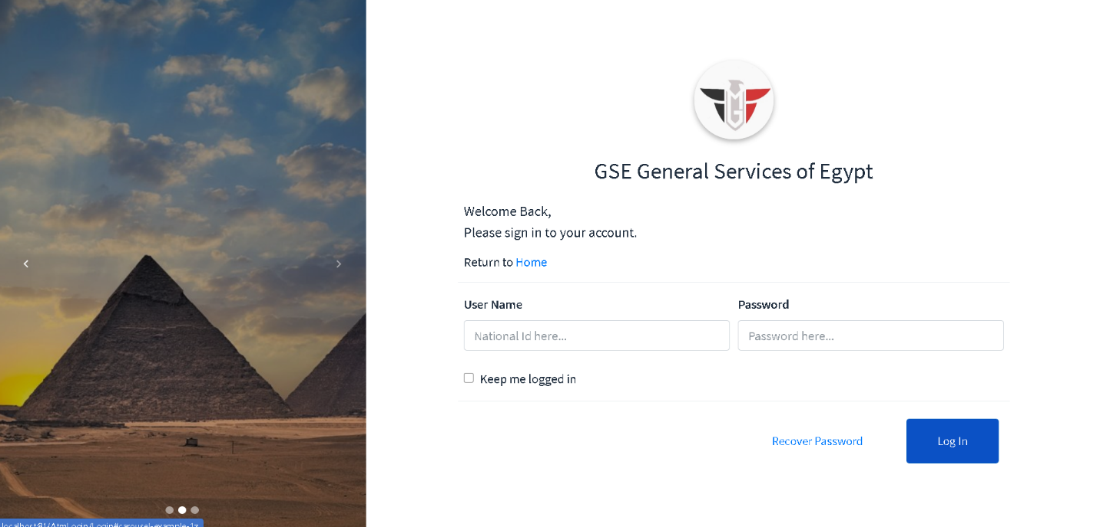

If the user entered Invalid national id/ username or password and choose his portal then clicks on “`login button” the system will display a message “Wrong username or password”

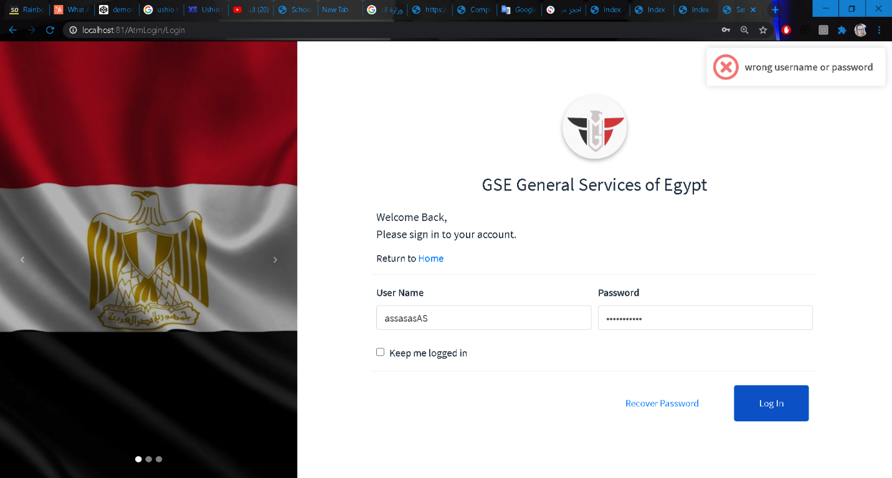

Else the system will redirect will to ministries page, then the user can choose the ministry that he/she want

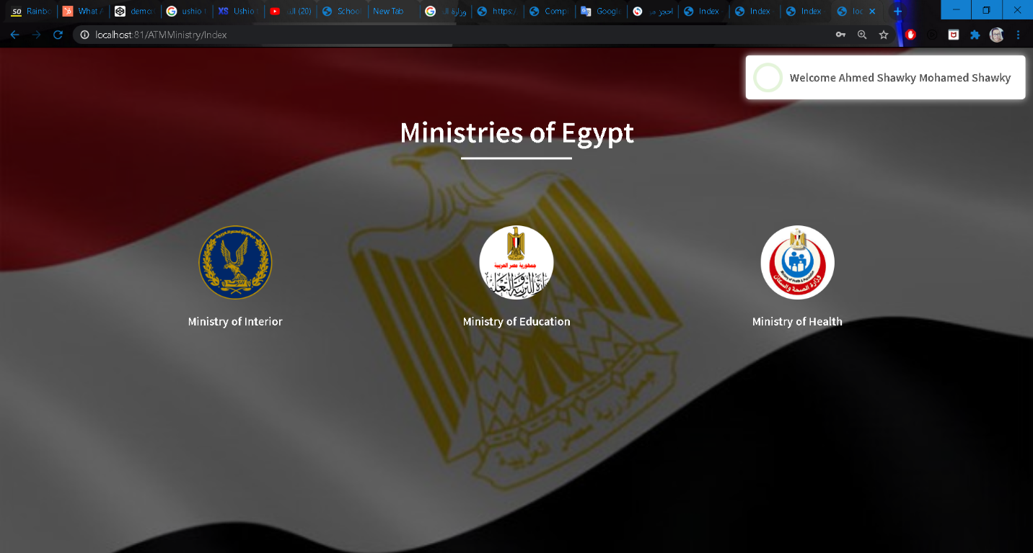

**Ministry of interior**

User can extract documents (Birth, Death and marriage/divorce) by clicking on “Civil affairs”

Then the system will redirect to a page that user can choose what he/she want to extract.

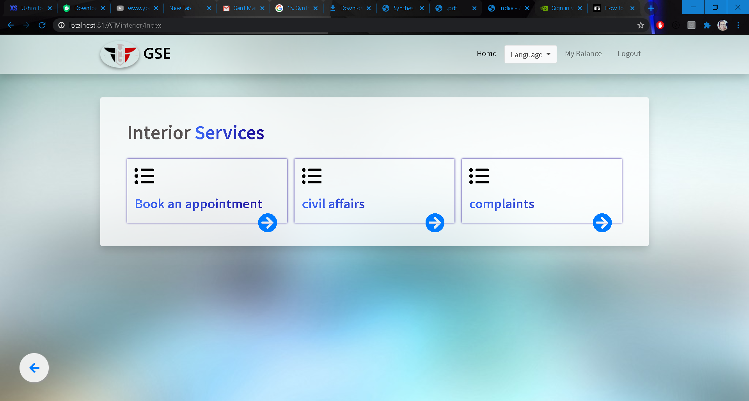

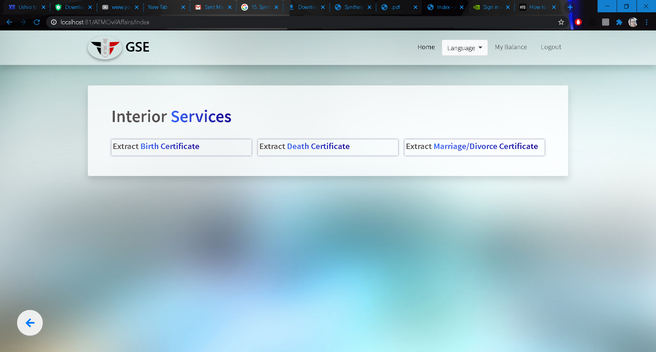

**Exporting Birth Document**

The system will display user’s information, the user could select and search by writing the national id of member of his/her family from a dropdown list then information of that member will displayed in the birth document area.

If the user click on “Export button” the system will print the birth document area and system will deduct the price of document from his/her account

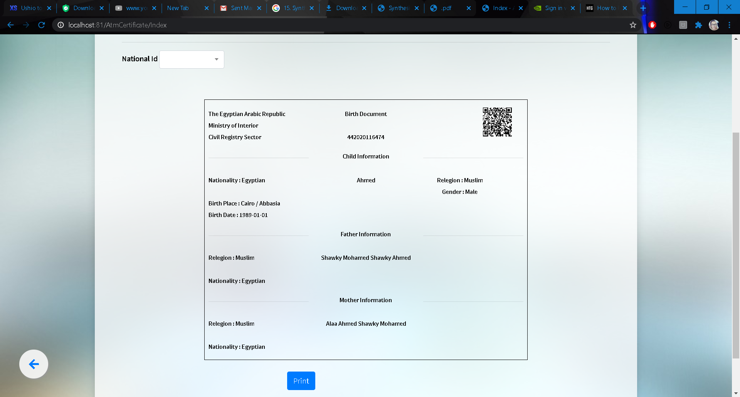

**Exporting Death Document**

The user can select and search by writing the national id of a member of his/her family from a dropdown list then information of that member will displayed in the death document area.

If the user click on “Export button” the system will print the death document area and system will deduct the price of document from his/her account

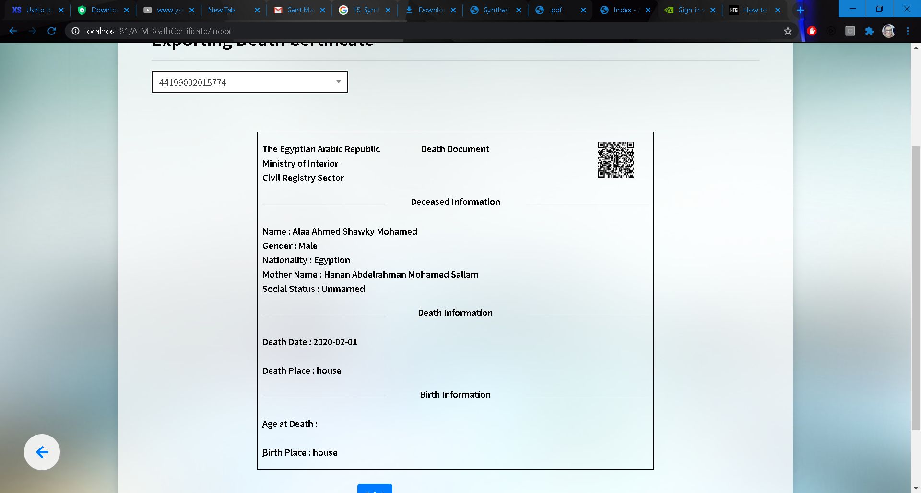

**Exporting Marriage / Divorce Document**

Whether user male or female he/she can choose type of social status (marriage/ divorce) then his/her husband/wife that have a relationship with user will appear in dropdown list of national id, so after selecting the national id the information of marriage/ divorce will displayed in document area, system will deduct the price of document from his/her account.

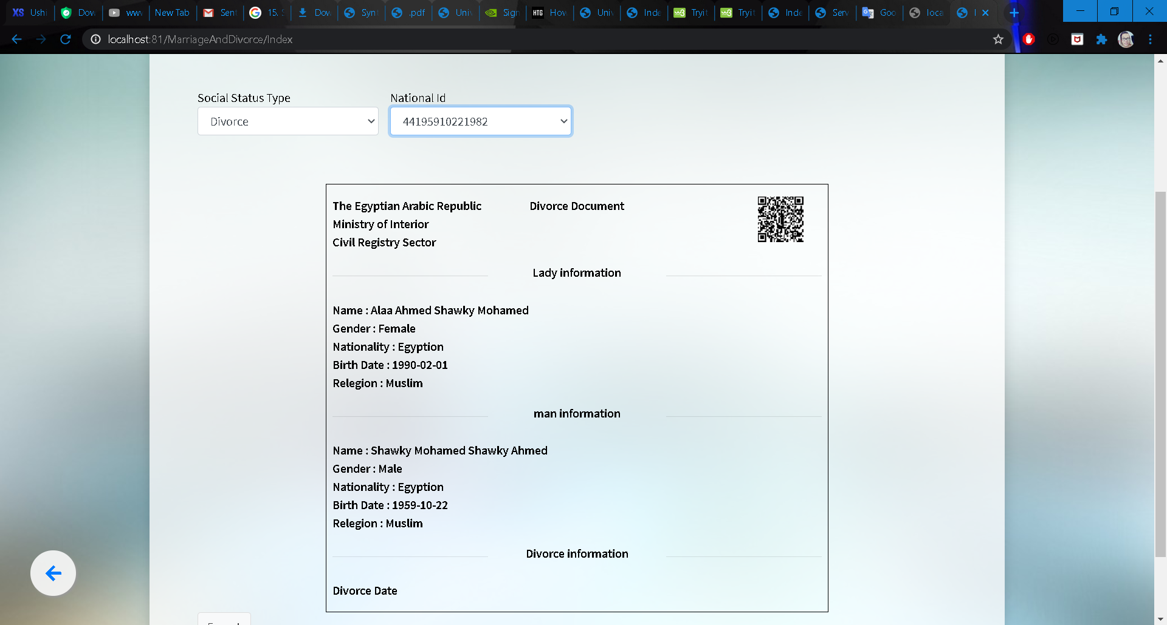

**Complaint**

The user can make complaint about anything he think that is wrong in the system or services, user shou1d fill the required field to complete his/her complaint

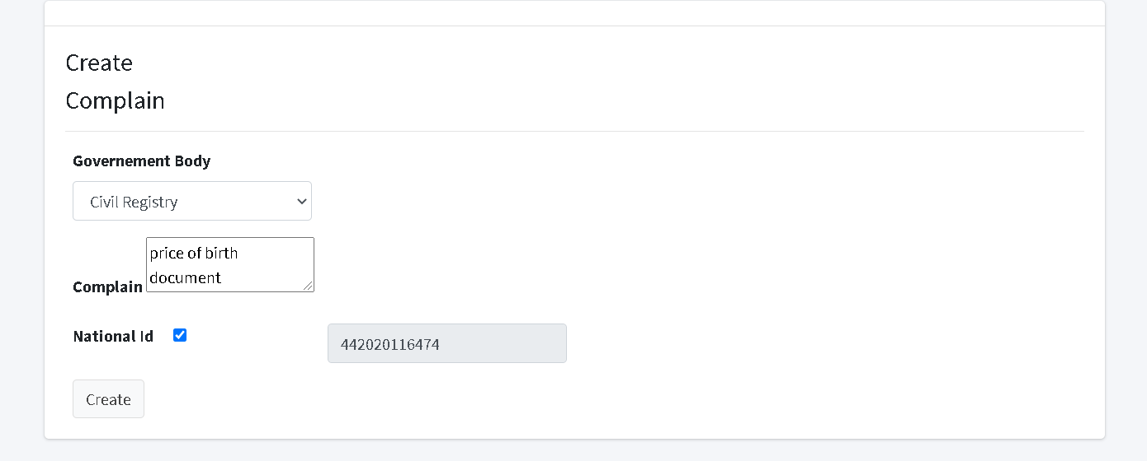

The system will redirect to the index page and display his/her complaints with the responds

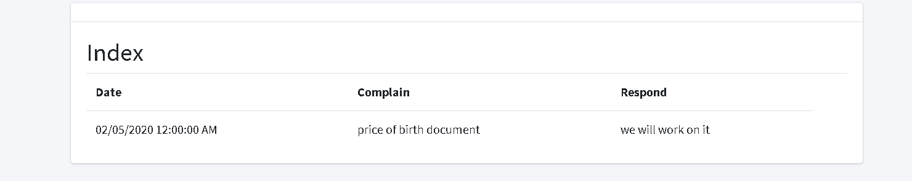

**Create reservation for civil registry**

The user must specify the government body and the service he want then choose the office by selecting its address (state, city, region and district) ,then click on the “reserve button”.

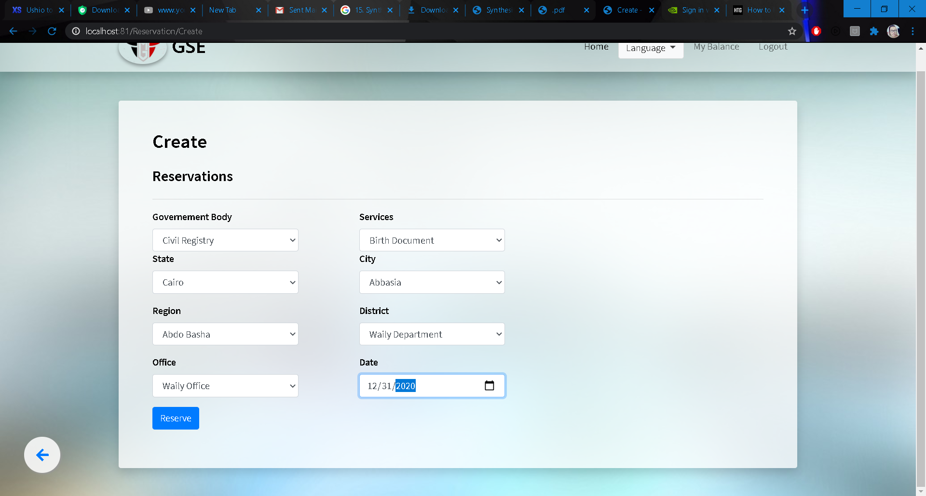

The system will redirect to the index page and display all reservations of the citizen

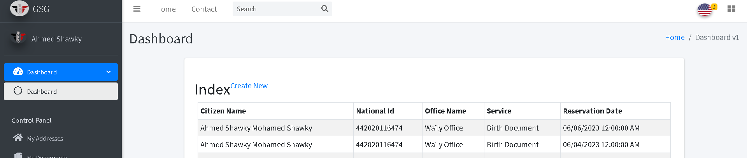

**Ministry Of Health**

User can book an appointment with doctor or for vaccination and can see his/her reservations

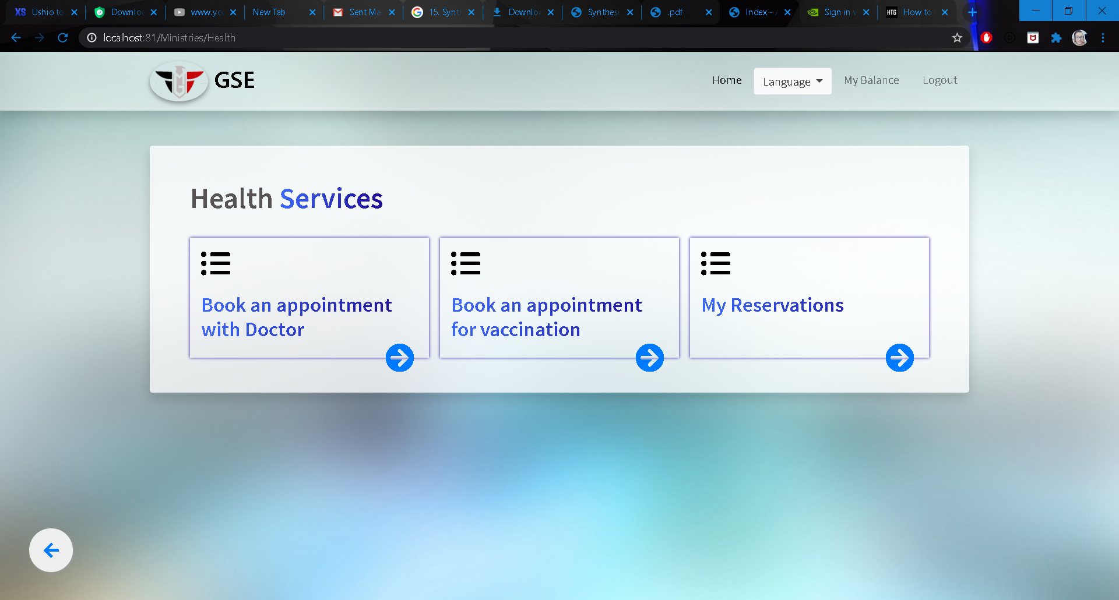

**Book an appointment with doctor**

The user must specify the health care type and the specialization he want then choose the health care by selecting its address (state, city, region and district).

The doctors will appear in the dropdown list after choosing health care, the user can select a doctor then the appointment of the doctor in this health care will displayed in appointment dropdown.

After filling the fields the user could click on “create button”

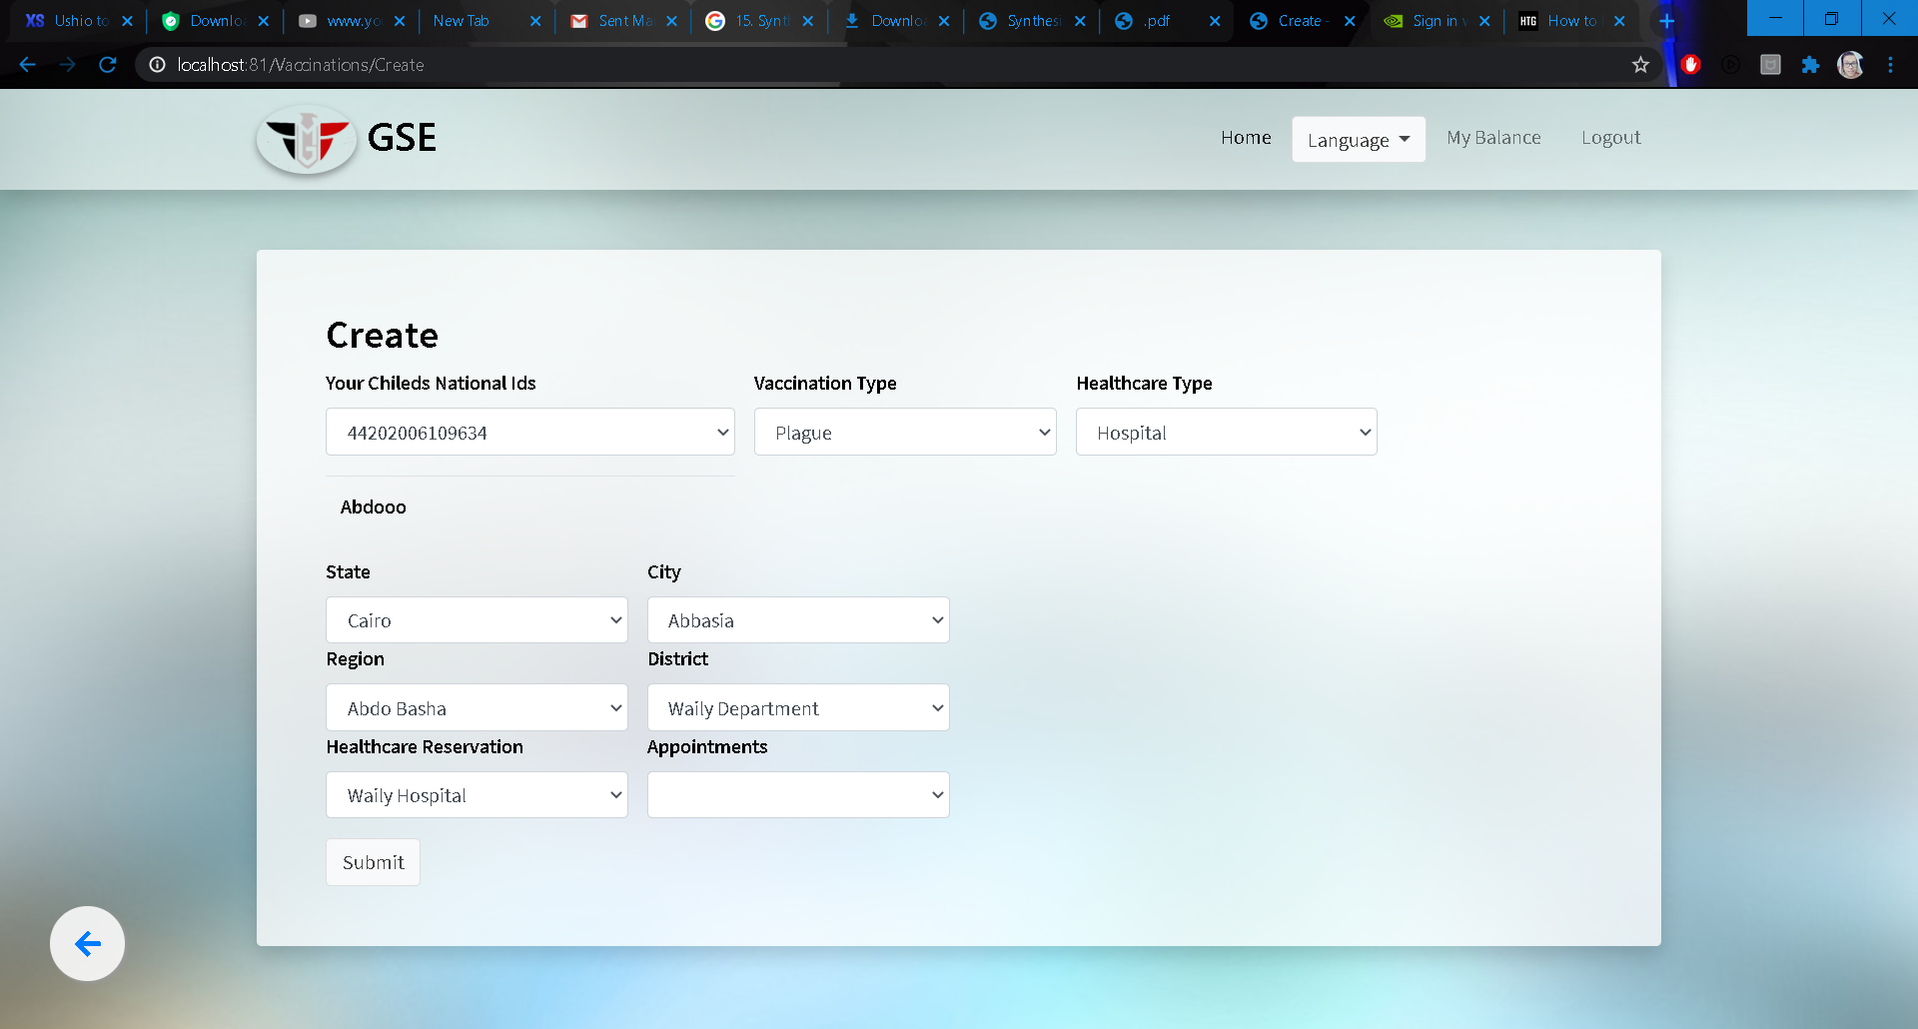

Then the system will respond with successful message

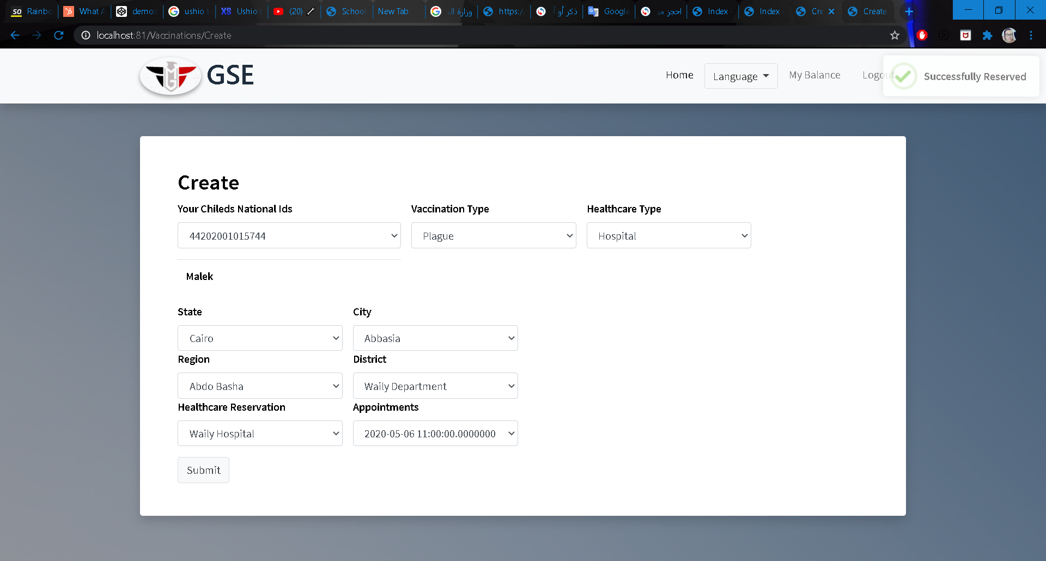

The system will redirect to the index page and display the citizen reservation that he make

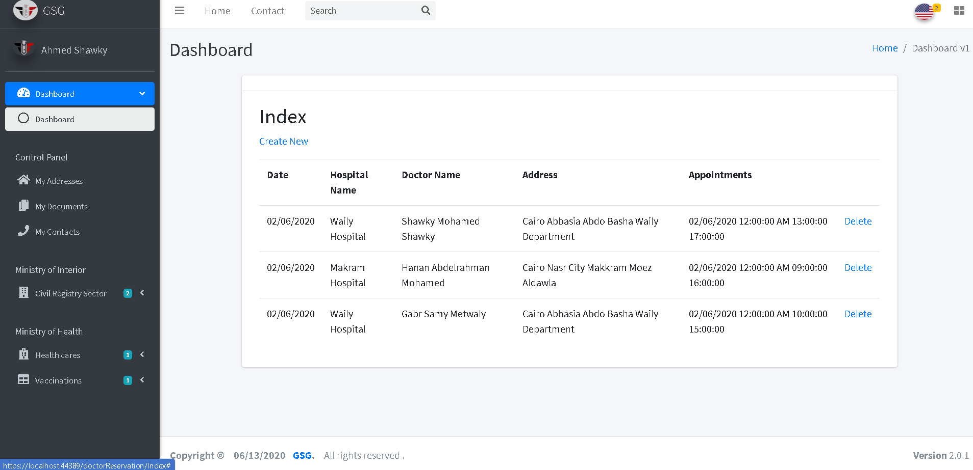

**Book an appointment for vaccination**

If the user has children he could make a reservation, the system will display first the children of the user and user must select the child then system will display the vaccination type that should the selected child take it and then choose the health care type and its address (state, city, region and district).

After that user can choose the appointment he want in this health care then click on “submit button”



Then the system will respond with successful message



**Ministry of education**

User can export his/her university and school certificates

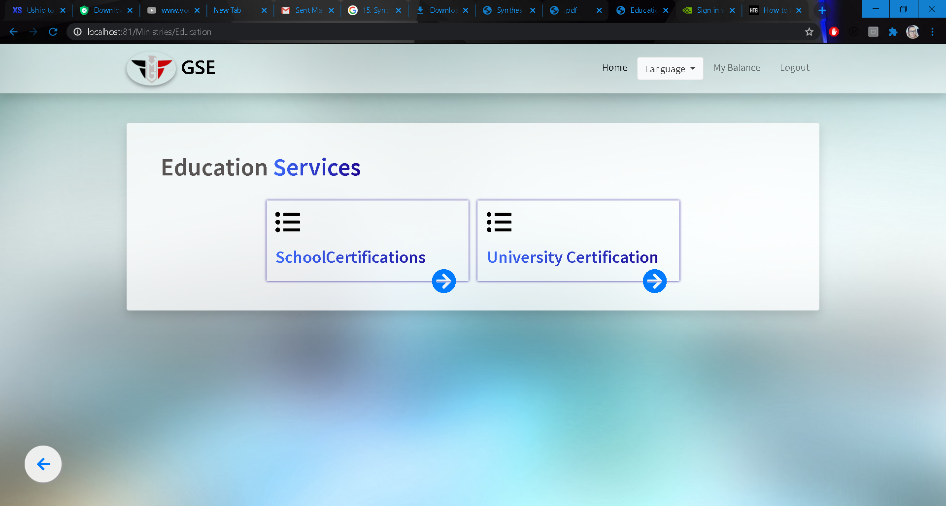

**School certifications**

User can get his/her school’s phase certificate by choose the phase from dropdown then the system will display all certificate information of him

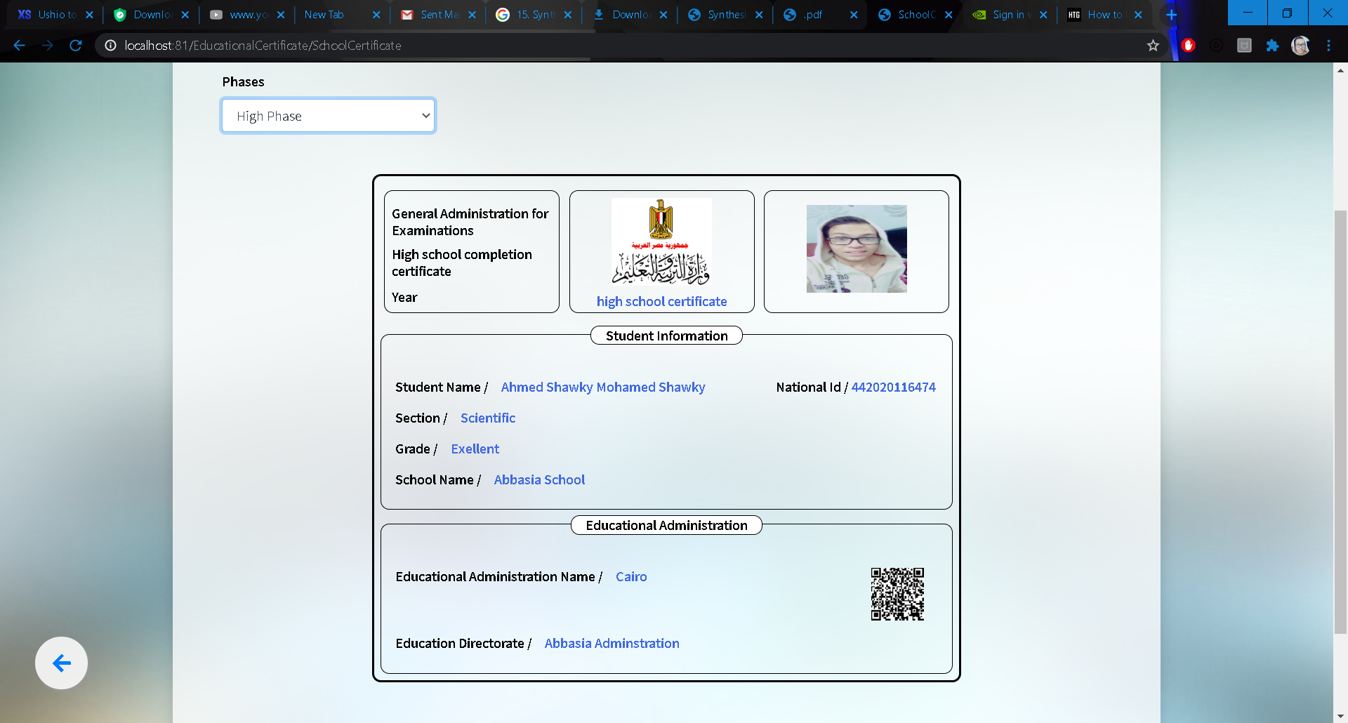

**University certificate**

The system will display university certificate information of the user and

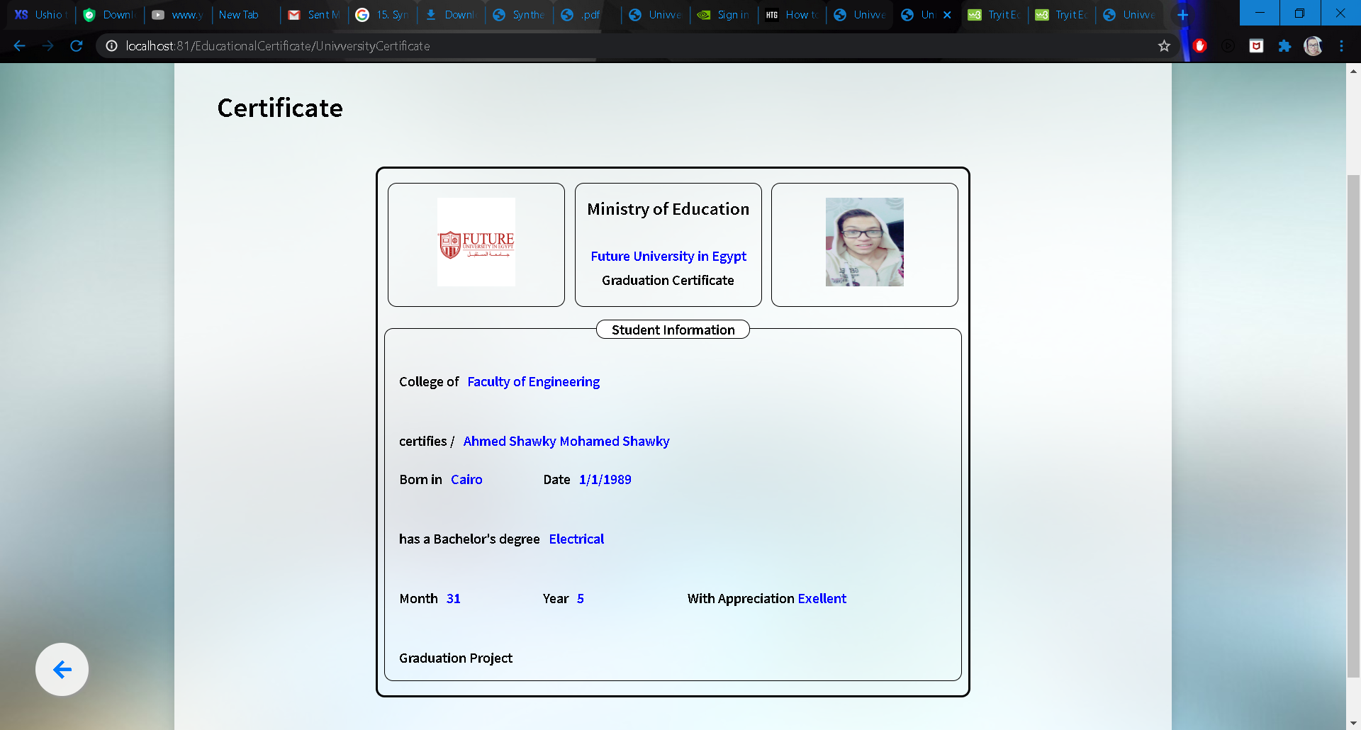

**User Balance**

User can see his/her account balance by clicking on “My Balance” button in the top right menu

